**INDEX**

|  |  |  |
| --- | --- | --- |
| **SR.NO.** | **CONTENT** | **PAGE** |
|  | **INTRODUCTION** | **3-7** |
|  | **RESEARCH METHODOLOGY** | **8-9** |
|  | **OBSERVATIONS** | **10** |
| **V.** | **SUGGESTIONS** | **29** |
| **VI.** | **CONCLUSION** | **30** |
| **VII.** | **REFERENCES** | **31** |

**INTRODUCTION**

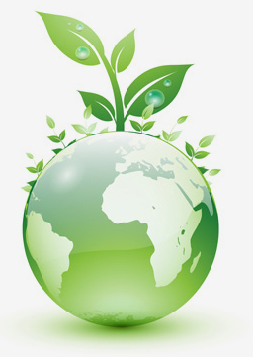

**ENVIRONMENT**

Earth is the only planet that has shown signs of life. Our planet that was born of fire has undergone change since its evolution and today it has emerged as a perfect system. The nature forces have given rise to an environment that was favorable for growth of life. These forces have gained a perfect balance and each other. Now the Earth looked more like a single living organism.

Earth’s environment can be divided into four divisions –atmosphere, biosphere, hydrosphere and lithosphere .Each of the sphere represents its own distinctive characteristics and supports the life forms on this planet in their own way.

The name of four spheres are derived from the Greek words for stone (litho) , air (atmo) ,water (hydro) and life (bio).All these spheres combine and have an interdependent relationship. They together create suitable conditions for the Earth.

* **Definition of Environment:-**

Many people have tried to define the term environment.

The term environment is derived from French word ‘Environner’ which means to encircle or to surround. All the biological and non biological entities surrounding us are included in environment. Environment is therefore defined as the sum total of water, air, land and the interrelationships that exist among them and the human being and other living things along with the materials. Some of the definitions are as follows:-

* **US Environment Agency:**

The sum of all external conditions affecting the life, development and survival of an organism.

* **Merriam-Webster Dictionary:**

The aggregate of social and cultural conditions that influence the life of an individual or community.

* **Components Of Environment:**

1. Biotic Components:

Biotic components contain all living organisms on planet. Many organisms in biotic components are classified as producers, consumers and Detroiters. This classification is based on what food they consume.

i)Producers:

Autotrophic organisms largely green plants,which are able to manufacture food from simple inorganic substance are called producers.chemosynthetic bacteria,photosynthetic bacteria,algae of various types,grasses,mosses,shrubs,herbs,& trees contribute in the total production of an ecosystem.

ii)Consumers:

These are the heterotrophic organisms,chiefly animals that eat ther organisms or organic matter.They may be herbivores or carnivores.They are called as macro consumers.

iii)Decomposers:

Heterotrophic organisms,chiefly bacteria and fungi that breakdown the complex compounds of dead protoplasm,absorb some of the products and release simple substances unable by the producers are called decomposers.

1. Non Biotic Components:-

These are the non living elements in the environment like latitude, altitude, location, climate, soil etc.

* Impact Of Development And Urbanizations On environment:

Development is the process which the standards of living. But it adversely affect on the environment. Some of these effects are social, such as breakdown of traditional values and way of life. Other negative effects are environmental pollution and depletion of natural resources. Impact of development is observed on following aspects:-

1. Changing the land:

The free land which is useful for agricultural purpose is cleaned and used for building purpose, industrial or factory purpose.

1. Deforestation:-

The total forest area of the world in 1900 was estimated to be 7000 million hectors which was reduced to 2890 million hectors , in year 1975 and again it fall down to 2300 million hectors by year 2000 due to development.

1. Land reclamation:
2. Resource depletion:
3. Pollution:

Due to development the pollution is increased on large scale. Various types of pollutants are produced to create various types of pollutions.

Ex. Soil pollution, air pollution, water pollution

1. Environmental Degradation:

* Environmental Conservation:

Human activities have been undertaken for benefit of mankind, but man has not been kind to nature and the result is nature has been unkind to him. Hence, there is need of environmental conservation.

To protect forest and wild life and to minimize water and air pollution. Some acts or policies or rules are been made by Government of India such as-

The Environmental Protection Act (1986), Water (Protection and Control) Act (1974), Air (Protection and Control) Act (1981), Motor Vehicle Act (1988), Noise Pollution law (2000).

Some of strategies that can be adopted for environmental conservation are-

1. Mass Education
2. Laws
3. Recycling
4. Constant Research
5. Innovation
6. Substitution
7. Adaptive management.

The wholes of sustainable development cannot be achieved by any Government at its own level until the public do not have participatory role. The public has to make aware about the environmental issues. There is one Chinese proverb-

“If you plan for one year, plant rice,

If you plan for ten years, plant trees,

If you plan for hundred tears, educate the people.”

If you want to save and protect our environment, we have no other option than making people environmentally educated.

.

**QUNATIFICATION AND MANAGEMENT OF BIOMEDICAL WASTE:-**

Hospital is one of the complex institution which is frequented by people every walk of life in society without any distinction between age, sex, race and religion. This is over and above the normal inhabitants of hospital that is patients and staff. All of them produce waste which is increasing in its amount and type due to advances in scientific knowledge and creating its impact.

1. The hospital waste, in addition to risk for patients and person who handle these wastes posses a threat to public health and environment.
2. Keeping in view inappropriate biomedical waste management, the Ministry of Environment and Forest notified the “Biomedical Waste (management and handling) Rules, 1998” in July 1998. In accordance with these rules (Rule 4), it is the duty of every occupier that is a person who has the control over institution and its promises, to take all steps to insure that the waste generator is handled without any adverse effect to health and environment. The hospitals, nursing homes, clinic, dispensary, animal house, pathological lab etc. are therefore required to set in place the biomedical waste treatment facilities. It is however, incumbent that every institution has to have its own waste treatment facility. The rules also envisage that common facility or any other facilities can be used for waste treatment. However, it is incumbent on the occupier to insure that the waste is treated within a period of 48 hours.

**RESEARCH METHODOLOGY**

The information related to project is collected from mainly hospitals, clinic, dispensary, nursing homes or pathological labs. We have visited the hospital for colletion of data.

* For completion of present study we have following objectives:-

1. To study concept of biomedical waste.
2. To study the sources of biomedical waste generation.
3. To study various characteristics of biomedical waste.
4. To study quantity of biomedical waste generated by hospital.
5. To study types of biomedical waste and quantity of each type of biomedical waste per day.
6. To study effects of biomedical waste on disposal site.
7. To study disposal methods of biomedical waste generated by hospital.
8. To suggest remedial measures of the disposal and management of biomedical waste.

* For the completion of present study we have following sample interview schedule:-

1. What is mean by biomedical waste?
2. What are the sources of biomedical waste?
3. How the biomedical waste is generated?
4. Where is biomedical waste generated?
5. How do you categorize the whole biomedical waste?
6. In how much quantity does biomedical waste generate?
7. Which are the types of biomedical waste?
8. What are the effects of biomedical waste?
9. What are the different disposal methods of biomedical waste?

**OBSERVATIONS**

We have collected all the information about hospital by research methodology technique. We have visited the hospital which generates Biomedical Waste and have collected the information.

* **NAME OF HOSPITAL:**

“SUSHRUSHA NURSING HOME”

Premature Baby Care Unit

Dr. Dipak Vasagadekar (M.D.)

* **ADDRESS:**

1422-C, near Satyavadi press, behind C.P.R., Laxmipuri, Kolhapur.

* **TYPE OF HOSPITAL:**

It is mainly the care unit of premature babies. Any type of operation or consultation of small babies is done in this hospital.

* **Capacity**: 200 patients
* **Year of Establishment**: 1994

**CHAPTER 4**

**SUMMARY AND FINDINGS**

* **BIOMEDICAL WASTE :-**

Biomedical wastes include a wide variety of items that may carry disease causing germs including those that cause hepatitis and virus that cause AIDS. It also includes items such as: live vaccines; laboratory samples; cultures; sharp needles; lancets that have been used to puncture, cut or scrape the body and human or animal body fluids or waste.

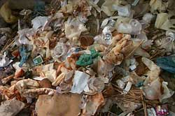 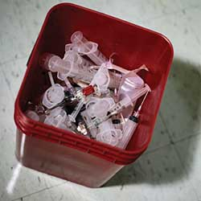

Because laboratories, hospitals and medical, clinics generate much of this waste, these facilities are required by law to follow procedures to protect the public from the contact with this waste.

Biomedical waste can also be created in homes and business so it is important for everyone to know about safe handling of this type of waste.

Bio-medical waste means any solid and/or liquid waste including its container and any intermediate product, which is generated during the diagnosis, treatment or immunisation of human beings or animals or in research pertaining thereto or in the production or testing thereof.The physico-chemical and biological nature of these components, their toxicity and potential hazard are different, necessitating different methods options for their treatment / disposal.Common producers of biomedical waste include [hospitals](http://en.wikipedia.org/wiki/Hospital), [health clinics](http://en.wikipedia.org/wiki/Health_clinic), [nursing homes](http://en.wikipedia.org/wiki/Nursing_home), [medical research](http://en.wikipedia.org/wiki/Medical_research) [laboratories](http://en.wikipedia.org/wiki/Laboratories), offices of [physicians](http://en.wikipedia.org/wiki/Physician), [dentists](http://en.wikipedia.org/wiki/Dentist), and [veterinarians](http://en.wikipedia.org/wiki/Veterinarian), [home health care](http://en.wikipedia.org/wiki/Home_health_care), and [funeral homes](http://en.wikipedia.org/wiki/Funeral_home).

Biomedical waste, also known as medical waste or infectious waste, is generally defined as any solid waste that is generated in the diagnosis, treatment, research, production or testing of biologicals for humans or animals.

* **Examples of Bio-Medical Waste:**
* soiled or blood-soaked bandages
* culture dishes and other glassware
* discarded surgical gloves ‒ after surgery
* discarded surgical instruments ‒ scalpels
* sharps and needles ‒ used to give shots or draw blood
* cultures, stocks, swabs used to inoculate cultures
* removed body organs ‒ tonsils, appendices,limbs, etc. (except teeth),lancets ‒ the little blades the doctor pricks.
* your finger with to get a drop of blood
* mercury and other metals, chemotherapy and antineoplastic chemicals, laboratory waste, acids, solvents, formaldehyde, photographic chemicals,radionuclides, expired pharmaceuticals, and waste anesthetic gases.

|  |
| --- |
|  |
|  |
|  |

Sometimes in a disaster situation, normal disposal systems for biomedical waste may be disrupted. When these disruptions occur, the disease risk from these waste increases.

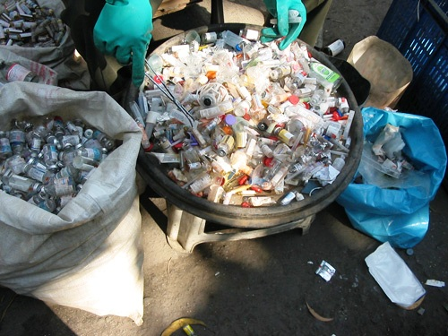

BIOMEDICAL WASTE

* **Sources of Biomedical Waste in hospital are as follows:**

1. Waste generated by operation:

Such as human parts, cotton, masks, gloves, syringes, blood, urine bags, material pads, tubes, catheters etc.

1. Waste generated by saline:

Saline bottles, saline liquid syringes, cotton, plastic etc.

1. Waste generated by bandages:

Bandages cloth, spirit balls, dressing material, blades etc.

* **The types of the Biomedical Wastes produced by hospital are as follows:**

1. Waste sharps:

Needles, syringes, scalpels, blades, glass.

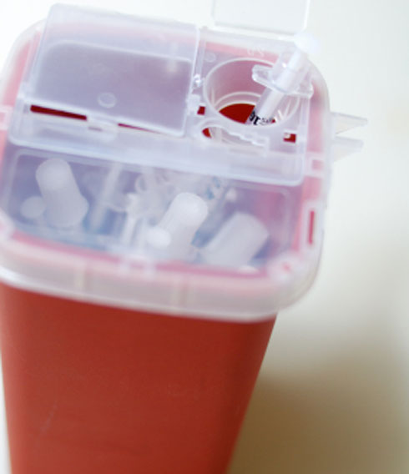 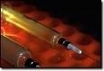

2. Soiled Waste:

Items contaminated with blood and body fluids including cotton, dressing, soiled plaster casts, lines, beddings, other material contaminated with blood.

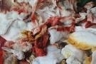

3. Solid Waste:

Tubing, catheters, intravenous sets etc.

4. Liquid Waste:

Waste from washing, disinfection activities.

* **The hospital categorizes all waste generated by following way:**

1. Yellow Bags:

Human parts, blood

1. Black Bags:

Spirit balls, dressing material, pads, bandages, plasters, cotton.

1. Red Bags:

Saline bottles, sets, catheters, urine bags, tubes, gloves etc.

1. Blue Bags:

Blades, syringes etc.

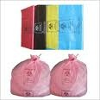 

Categorization of biomedical waste

* **The hospital generates the biomedical waste which is categorized in different bags per month:-**

1. Yellow Bags-1000 kg.

2. Red Bags-3800 kg.

3. Black Bags-800 kg.

4. Blue Bags-500 kg.

* **Classification of biomedical waste :-**

There are different types of biomedical wastes as given below:

1. Human anatomical waste
2. Animal waste
3. Microbiology waste
4. Soiled waste
5. Solid waste
6. Discarded waste
7. Chemical waste
8. Waste sharps

**Who is covered by this rule?**

All persons handling biomedical waste disposal,including but not limited to: ambulatory service centers, blood banks, clinics, county health departments, dental offices, funeral homes,health maintenance organizations (HMOs),hospitals, laboratories, medical buildings,physicians offices, veterinary offices, research and manufacturing facilities, nursing homes,and biomedical waste transportation, storage,treatment, and disposal facilities.

**Storage and containment of biomedical waste:-**

• stored in a manner and location that is protected from weather and animals and does not provide a breeding place or food source for insects or rodents. Exposure to the public should be minimized.

• placed in a container separate from other Wastes.

• stored in containers so as to prevent leakage, punctures, and ripping during storage, handling and transportation.

• containers shall be red or orange in color OR clearly marked with the universal biohazard symbol (seen to the right) OR clearly marked with the word “biohazard.”

#### **LABEL FOR BIO-MEDICAL WASTE CONTAINERS/BAGS:-**

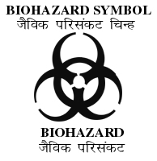  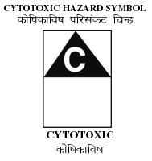

**BIOMEDICAL PIE-CHART:-**

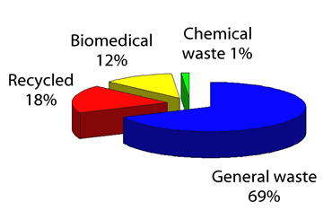

**WASTE MANAGEMENT:-**

Waste management is the collection, transport, processing, recycling or disposal, and monitoring of waste materials. The term usually relates to materials produced by human activity and is generally undertaken to reduce their effect on health, the environment or aesthetics. Waste management is also carried out to recover resources from it. Waste management can involve soli, gaseous, or radioactive substances with different methods and fields of expertise of each.

Management of non-hazardous residential and institutional waste in metropolitan areas is usually the responsibility of local government authorities, while management for non-hazardous commercial and industrial waste is usually the responsibility of generator.

For biomedical waste management, the hospital adopts the rules of “DAAS” waste management. The categorized waste is then collected by “DAAS” service of Kolhapur Municipality. They collect the waste and dispose it by any way like incineration, microwave, autoclave, landfill, deep burial, chemical treatment like disinfection etc.

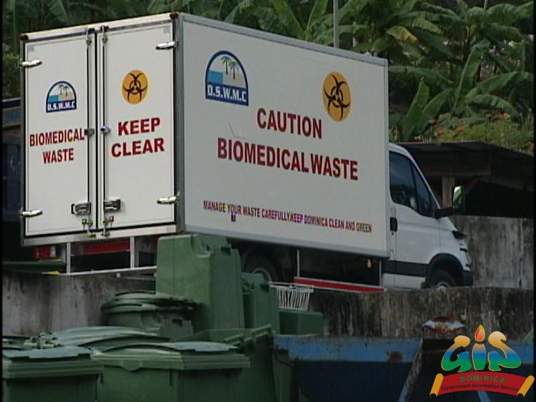 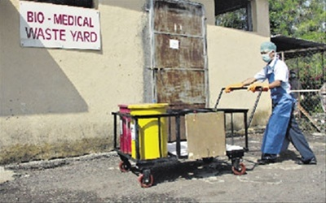

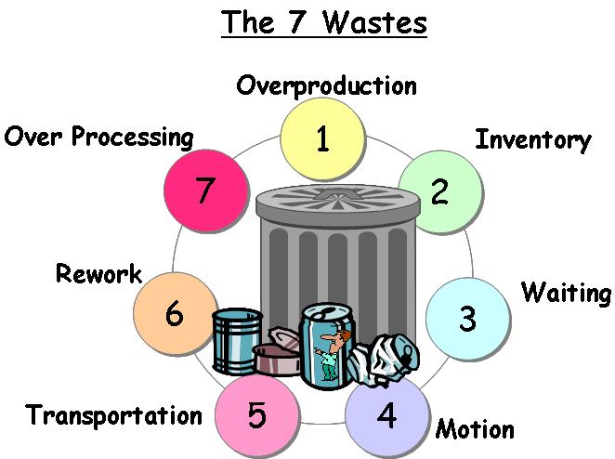

* **Disposal of biomedical waste:-**

Handling, segregation, mutilation, disinfection, storage, transportation, and final disposal are vital steps for safe and scientific management of biomedical waste in any establishment. The key to minimization and effective management of biomedical waste is segregation (separation) and identification of the waste. The most appropriate way of identifying the categories of biomedical waste into the color coded plastic bags or containers.

**Example:-**

|  |  |  |  |
| --- | --- | --- | --- |
| Sr. no. | Color of Bag | Type of Bag | Type of Waste |
| 1.  2.  3. | Yellow  Red  Black | Plastic bags  Disinfected containers  Plastic bags | Human anatomical waste, animal waste  Solid waste  Chemical waste, discarded medicines. |

General waste like garbage garden refuse etc should join the stream of domestic refuse. Sharps should be collected in puncture proof containers. Bags and containers for infectious wastes should be marked with biohazard symbol. Highly infectious waste should sterilized by autoclaving. Cytotoxic wastes are to be collected in leak proof containers, clearly labeled as cytotoxic wastes. Needles and syringes should be destroyed with the help of needle destroyer and syringe cutter provided at the point of generation. Infusion sets, bottles, gloves should be cut with curved seizers.

Disinfection of sharps soil linen, plastic and rubber good is to be achieved at the point of generation by usage of sodium hypochlorite with minimum contact of one hour. Fresh solution should be made in each shift on site on collection requires staff to close the waste bags, when they are quarters full either by tying the neck or by scaling the bag, Curbsides storage area needs to be impermeable and hard standing with good drainage. It should provide an easy access to waste collection vehicle.

Biomedical waste should be within the hospital by means of trolleys, carts, or containers that are not used for any other purpose. The trolleys have to be cleaned daily. Offsite transportation vehicle should be marked with the name and address of carrier. Biohazard symbol should be painted. Suitable system for securing the load during transportation should be insured. Such a vehicle should be easily cleanable with rounded corners.

All disposable plastic should be subjected to shredding before disposal off to vendor.

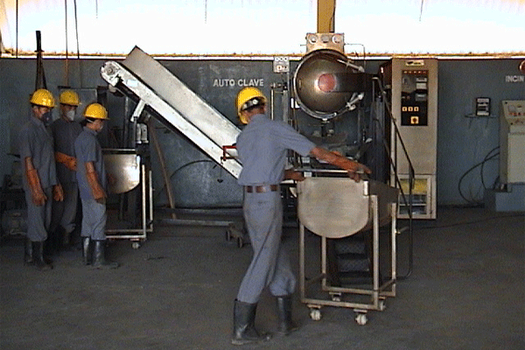

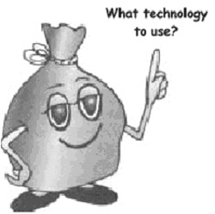

**Bio-Medical Technologies:-**

Biomedical waste can be done by following technologies:-

* **Incineration:-**

This is a high temperature thermal process employing combustion of the waste under controlled condition for converting them into inert material and gases.Incinerators can be oil fired or electrically powered or a combination thereof.Broadly, three types of incinerators are used for hospital waste : multiple hearth type, rotary kiln and controlled air types. All the types can have primary and secondary combustion chambers to ensure optimal combustion. These are refractory lined.In the multiple hearth incinerator, solid phase combustion takes place in the primary chamber whereas the secondary chamber is for gas phase combustion. These are referred to as excess air incinerators because excess air is present in both the chambers.

The rotary kiln is a cylindrical refractory lined shell that is mounted at a slight tilt to facilitate mixing and movement of the waste inside. It has provision of air circulation. The kiln acts as the primary solid phase chamber, which is followed by the secondary chamber for the gaseous combustion.

* **Autoclave Treatment:-**

This is a process of steam sterilisation under pressure. It is a low heat process in which steam is brought into direct contact with the waste material for duration sufficient to disinfect the material. These are also of three types : Gravity type, Pre-vacuum type and Retort type. In the first type (Gravity type), air is evacuated with the help of gravity alone.

The system operates with temperature of 121 deg. C. and steam pressure of 15 psi. for 60-90 minutes. Vacuum pumps are used to evacuate air from the Prevacuum autoclave system so that the time cycle is reduced to 30-60 minutes. It operates at about 132 deg. C. Retort type autoclaves are designed to handle much larger volumes and operate at much higher steam temperature and pressure. Autoclave treatment has been recommended for microbiology and biotechnology waste, waste sharps, soiled and solid wastes .This technology renders certain categories of bio-medical waste innocuous and unrecognisable so that the treated residue can be landfilled. Sanjay Gandhi Memorial Hospital in Delhi has installed a Prevacuum.

* **Hydroclave Treatment:-**

Hydroclave is an innovative equipment for steam sterilisation process. It is a double walled container, in which the steam is injected into the outer jacket to heat the inner chamber containing the waste. Moisture contained in the waste evaporates as steam and builds up the requisite steam pressure (35-36.waste continuously against the hot wall thus mixing as well as fragmenting the same. In the absence of enough moisture, additional steam is injected. The system operates at 132 deg.C. and 36 psi steam pressure for sterilisation time of 20 minutes. The total time for a cycle is about 50 minutes, which includes start-up, heat-up, sterilisation, venting and depressurisation and dehydration. The treated material can further be shredded before disposal. The expected volume and weight reductions are upto 85% and 70% respectively.

* **Microwave Treatment:-**

This again is a wet thermal disinfection technology but unlike other thermal treatment systems, which heat the waste externally, microwave heats the targeted material from inside out, providing a high level of disinfection. The input material is first put through a shredder. The shredded material is pushed to a treatment chamber where it is moistened with high temperature steam.

* **Chemical Disinfecting:-**

This treatment is recommended for waste sharps, solid and liquid wastes as well as chemical wastes. Chemical treatment involves use of at least 1% hypochlorite solution with a minimum contact period of 30 minutes or other equivalent chemical reagents such as phenolic compounds, iodine, hexachlorophene, iodine-alcohol or formaldehyde-alcohol combination etc. Preshredding of the waste is desirable for better contact with the waste material. In the USA, chemical treatment facility is also available in mobile vans. In one version, the waste is shredded, passed through 10% hypochlorite solution (dixichlor) followed by a finer shredding and drying. The treated material is landfilled.

* **Sanitary and Secured Landfilling:-**
* Disposal of autoclaved/hydroclaved/microwaved waste (unrecognisable) -

Sanitary landfill.

* Disposal of incineration ash - Sanitary landfill.
* Disposal of bio-medical waste till such time when proper treatment and

disposal facility is in place - Secured landfill.

* Disposal of sharps - Secured landfill. This can also be done within a

hospital premises as mentioned below.

In case disposal facility for sharps is not readily available in a town, health

care establishments, especially hospitals having suitable land, can construct a

concrete lined pit of about 1m length, breadth and depth and cover the same with a heavy concrete slab having a 1 - 1.5 m high steel pipe of about 50 mm diameter.

* Disinfected sharps can be put through this pipe. When the pit is full, the pipe

should be sawed off and the hole sealed with cement concrete. This site should notbe water logged or near a borewell.

**METHODS OF DISPOSAL:-**

* **Landfill :**

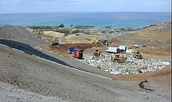

Disposing of waste in landfill involves burying the waste and this remains a common practice in most countries. Landfills were often established in abundant or unused quarries, mining voids or borrow pits. A properly-designed and well-managed landfill can be hygienic and relatively inexpensive method of disposing of waste materials.

Another common byproduct of landfills is gas which is produced as organic waste breaks down anaerobically. This gas can create older problem, kill surface vegetation and is greenhouse gas. Many landfills also have landfill gas extraction system installed to extract the landfill gas.

* **Incineration :**

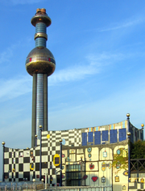

It is a disposal method that involves combustion of waste material. Incineration and other high temperature waste treatment systems are sometimes described as “Thermal Treatment”. Incinerators convert waste material into heat, gas, steam, ash.It used on a large scale by industry. It is used to dispose of solid, liquid and gaseous waste.

* **Plasma Gasification :**

Plasma is highly ionized or electrically charged gas. An example in nature is lightning, capable of producing temperature exceeding 12,600 F.The process results in elemental destruction of waste and hazardous materials. Plasma gasification offers state new opportunities for waste disposal and more importantly for renewable power generation in an environmentally sustainable manne.

* **Recycling :**

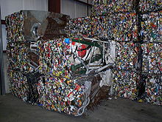

Recycling refers to the collection and reuse of waste materials such as empty beverage containers. The materials from which the items are made can be reprocessed into new products. Material for recycling may be collected separately from general waste using dedicated bins and collection vehicles, or sorted directly from mixed waste streams. The most common consumer products recycled include [aluminum](http://en.wikipedia.org/wiki/Aluminum) such as beverage cans, [copper](http://en.wikipedia.org/wiki/Copper) such as wire, [steel](http://en.wikipedia.org/wiki/Steel) food and aerosol cans, old steel furnishings or equipment , [polyethylene](http://en.wikipedia.org/wiki/HDPE) and [PET](http://en.wikipedia.org/wiki/Recycling_of_PET_Bottles) bottles, [glass](http://en.wikipedia.org/wiki/Glass) bottles and jars, [paperboard](http://en.wikipedia.org/wiki/Paperboard) [cartons](http://en.wikipedia.org/wiki/Carton), [newspapers](http://en.wikipedia.org/wiki/Newspapers), magazines and light paper, and [corrugated fiberboard](http://en.wikipedia.org/wiki/Corrugated_fiberboard) boxes.

* **Sustainability :**

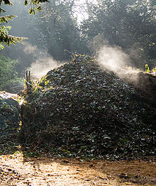

The management of waste is a key component in a business' ability to maintaining ISO14001 accreditation. Companies are encouraged to improve their environmental efficiencies each year. One way to do this is by improving a company’s waste management with a new recycling service.such as recycling: glass, food waste, paper and cardboard, plastic bottles etc.

* **Biological reprocessing :**

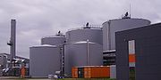

Waste materials that are organic in nature, such as plant material, food scraps, and paper products, can be recycled using biological composting and digestion processes to [decompose](http://en.wikipedia.org/wiki/Decompose) the organic matter. The resulting organic material is then recycled as [mulch](http://en.wikipedia.org/wiki/Mulch) or [compost](http://en.wikipedia.org/wiki/Compost) for agricultural or landscaping purposes. In addition, waste gas from the process such as methane can be captured and used for generating electricity and heat CHP/cogeneration maximising efficiencies. The intention of biological processing in waste management is to control and accelerate the natural process of decomposition of organic matter.There is a large variety of composting and digestion methods and technologies varying in complexity from simple home compost heaps, to small town scale batch digesters, industrial-scale enclosed-vessel digestion of mixed domestic waste Methods of biological decomposition are differentiated as being [aerobic](http://en.wikipedia.org/wiki/Aerobic_decomposition) or [anaerobic](http://en.wikipedia.org/wiki/Anaerobic_digestion) methods, though hybrids of the two methods also exist. Anaerobic digestion of the organic fraction of MSW Municipal Solid Waste has been found to be in a number of LCA analysis studies to be more environmentally effective, than landfill, incineration or pyrolisis.

The resulting biogas i.e.methane though must be used for cogeneration and can be used with a little upgrading in gas combustion engines or turbines. With further upgrading to synthetic natural gas it can be injected into the natural gas network or further refined to hydrogen for use in stationary cogeneration fuel cells. Its use in fuel cells eliminates the pollution from products of combustion.

* **Energy recovery :**

The energy content of waste products can be harnessed directly by using them as a direct combustion fuel, or indirectly by processing them into another type of fuel. Recycling through thermal treatment ranges from using waste as a fuel source for cooking or heating, to anaerobic digestion and the use of the gas fuel to fuel for [boilers](http://en.wikipedia.org/wiki/Boilers) to generate steam and electricity in a [turbine](http://en.wikipedia.org/wiki/Turbine). [Pyrolysis](http://en.wikipedia.org/wiki/Pyrolysis) and [gasification](http://en.wikipedia.org/wiki/Gasification) are two related forms of thermal treatment where waste materials are heated to high temperatures with limited [oxygen](http://en.wikipedia.org/wiki/Oxygen) availability. The process usually occurs in a sealed vessel under high [pressure](http://en.wikipedia.org/wiki/Pressure). Pyrolysis of solid waste converts the material into solid, liquid and gas products. The liquid and gas can be burnt to produce energy or refined into other chemical products . The solid residue can be further refined into products such as [activated carbon](http://en.wikipedia.org/wiki/Activated_carbon). Gasification and advanced [Plasma arc gasification](http://en.wikipedia.org/wiki/Plasma_arc_gasification) are used to convert organic materials directly into a synthetic gas composed of [carbon monoxide](http://en.wikipedia.org/wiki/Carbon_monoxide) and [hydrogen](http://en.wikipedia.org/wiki/Hydrogen). The gas is then burnt to produce electricity and [steam](http://en.wikipedia.org/wiki/Steam). An alternative to pyrolisis is high temperature and pressure supercritical water decomposition .

**Protection from Biomedical Waste:-**

Wash your hands with soap and warm water after handling biomedical waste. Also, wash all areas of your body with soap and water that you think may have come into contact with biomedical waste, even if you are not sure your body actually touched the biomedical waste.

* Keep all sores and cuts covered.
* Immediately replace wet bandages with clean, dry bandages.
* Wear disposable latex gloves when handling biomedical waste. Discard the gloves immediately after use.
* Wear an apron or another type of cover to protect your clothes from contact with the waste. If your clothes become soiled, put on fresh clothes, and take a shower, if possible.
* Launder or throw away clothes soiled with biomedical waste.
* Promptly clean and disinfect soiled, hard-surfaced floors by using a germicidal or bleach solution and mopping up with paper towels.
* Clean soiled carpets. First blot up as much of the spill as possible with paper towels and put the soiled paper towels in a plastic lined, leak-proof container. Then try one of the following:
* Steam clean the carpet with an extraction method.
* Scrub the carpet with germicidal rug shampoo and a brush. Soak the brush used for scrubbing in a disinfectant solution and rinse the brush. Let the carpet dry, and then vacuum it.
* Never handle syringes, needles, or lancets with your hands. Use a towel, shovel, and/or broom and a dustpan to pick up these sharp objects. Dispose of them in a plastic soda pop bottle with a cap. Tape down the bottle cap. Then throw the bottle in the trash.

**SUGGESTIONS**

It is the duty of every “occupier” i.e. a person who has the control over the institution and it’s premises, to take all steps to ensure that waste generated handled without any adverse effect to human health and environment.

The waste generated within the hospital is not packed immediately, which is very dangerous for surrounding environment.

Also, the waste carried by ‘DAAS’ committee is thrown out of city but on the open space as well as it is not disposed for long period.

We would like to suggest them to pack the waste generated immediately and dispose that waste as early as possible i.e. within 48 hours.

**CONCLUSION**

* Segregation of the hospital wastes according to the available disposal

technology.

* Employment of cost-effective and available relevant technology.

Possibilities of recycling to be explored in a scientific and hygienic manner for

permissible items.

* Setting up of common medical waste treatment facilities for/by different

hospitals such as transportation of the hazardous waste to the common

disposal system to reduce expenditure.

* Safety of medical staff/rag-pickers, by the use of gloves and masks and

housekeeping aspects (drinking water, sewage system of the hospitals).

Implementation of recycling etiquette by medical and paramedical personnel.

Training of Municipality workers by medical personnel in handling of medical

waste to avoid risks and health hazards.

* Implementations of legislations pertaining to hygiene of freelance workers such as rag pickers in the recycling industry.
* The management of biomedical wastes poses a great challenge to the policy

planners, city administrators, medical personnel and workers in the recycling industry. 6.There is a need for adopting a cost-effective system for providing better medical waste treatment facilities and reduce the amount of waste generation by awareness and education of all concerned.

**REFERENCES**

* 1. **Dr.Samant J.S.’’Environmental Studies’, Shivaji University, Kolhapur,2010.**
  2. [**www.wikipedia.com**](http://www.wikipedia.com/)
  3. **ww.wikimapia.com**